The Knights Radiant Recruitment Hub Site Plan

Cole Purser

WDD 130

Overview

Purpose
To give information and interactive experiences about the knights Radiant from Brandon Sandersons Stormlight Archive.

Audience
For either fans of Brandon Sandersons Stormlight Archive, and anyone who is curious.

Branding

Website Logo


Style Guide

Color Palette
Primary | Secondary | Accent 1 | Accent 2
#1a2a39ff | #dac097ff | #fef6dfff | #666666ff

Typography

Heading Font: Kings

https://fonts.google.com/specimen/Kings?preview.text=The%20Knights%20Radiant%20Recruitment%20Hub&categoryFilters=Appearance:%2FTheme%2FMedieval;Feeling:%2FExpressive%2FSophisticated

Paragraph Font: Modern Antiqua

https://fonts.google.com/specimen/Modern+Antiqua?preview.text=Powers:%20Windruners%20have%20the%20surges%20of%20Gravitation%20and%20adhision&categoryFilters=Appearance:%2FTheme%2FMedieval

Import Link: @import url('https://fonts.googleapis.com/css2?family=Kings&family=Modern+Antiqua&display=swap');

Navigation
Home Radiant Orders The Tower

Content

Home Screen

[Logo:]

[Hero Img:]
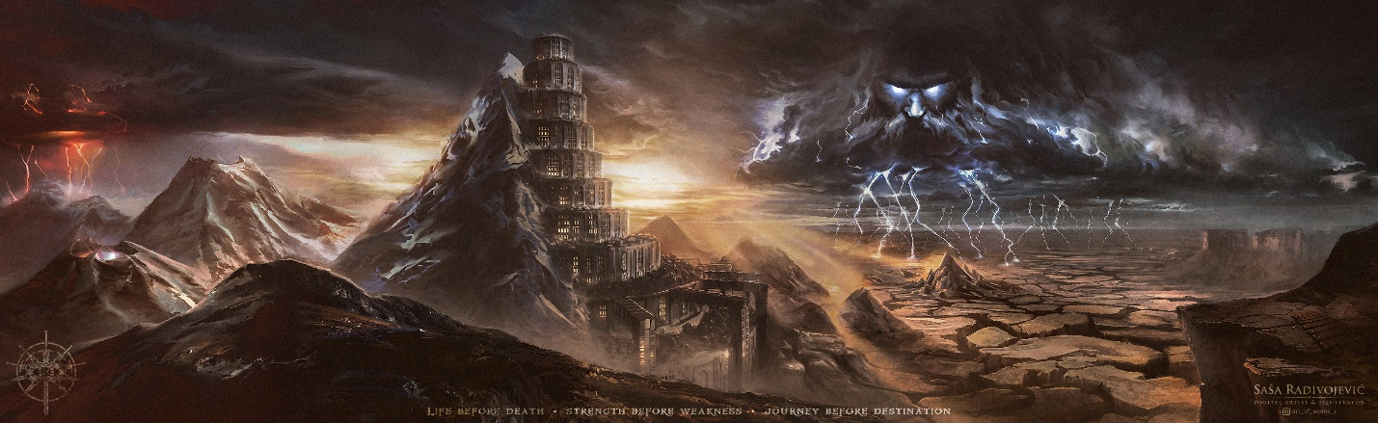
[Photo of Dalinar:]
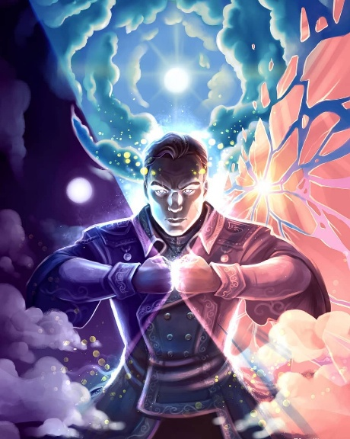
[Introductory Paragraph:]

I, Dalinar Kholin, write this in hopes that this will be seen by all who wish to defend that which they love against the forces of evil. I’m the leader of an ancient group known as the Knights Radiant. We are ten distinct orders of men and women who swear powerful oaths and gain extraordinary abilities to defend our world from a rising threat called the God of Passion, or Odium and his army of powerful Singers, a super race unlike anything anyone has seen before. Odium seeks the destruction of Roshar and all Humankind. Our purpose as Knights Radiant is to stop them. Every order has its own purpose: protectors, scouts, healers, scholars, diplomats, and warriors alike, all united in the defense of Roshar, but all are bound by ideals of responsibility, honor, and improvement. In this record, you will learn what each order stands for, what qualities its members must embody, and how its strengths contribute to our survival. Some orders have grown strong; others are in dire need of new recruits. If you feel the desire to protect, to build, to lead, or simply to become better than you were before, then there may be a place for you among the Knights Radiant. Come and unite with us, for the good of all.

[Map of Roshar:]
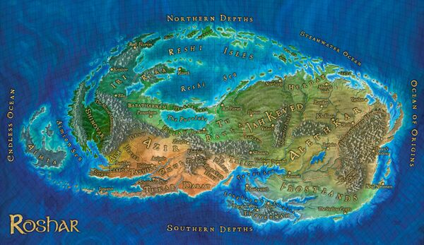
[Photo of the Tower City of Urithiru]
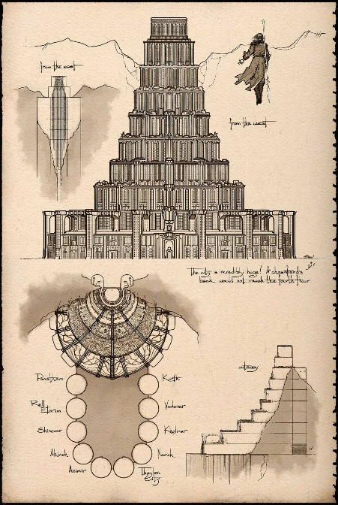
[Paragraph About Urithiru]
Urithiru is the heart of the Knights Radiant—a towering city carved into the peaks where the air is clear, and the mind can rise unhindered. Here, the ten orders once trained, studied, and governed together, each contributing their strengths for the good of all. Its halls hold room for learning, strategy, rest, and reflection, and its height reminds us that the Radiants must always strive upward in purpose and character. Should you take up the ideals and join us, Urithiru will stand as your home, your refuge, and a place where you may become the person you were meant to be.

Page 1: Radiant Order Info

[For the Header Img just use the part of the Hero Img that has the storm father. If that doesn’t work just position it around so a part of it looks cool use the same for the footer. Ignore the photo I put in the wireframe]

[Windrunner Logo:]
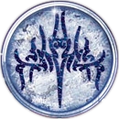
[Windrunner Info Card]

Windrunner:
-Ideal: I will protect
-Spren Companion: Honor Spren
-Surges: Adhesion and Gravitation
-Description: Windrunners use their surges/powers, manipulate gravity, to fly, and launch themselves through the air, using magical bonds to strengthen protections and defend those who cannot protect themselves.

[Edgedancer Logo]
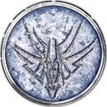
[Edgedancer info card]
Edgedancer:
-Ideal: I will remember
-Spren Companion: Cultivation Spren
-Surges: Abrasion and Progression
-Description: Agile healers who can heal others with magical energy and glide frictionlessly across any surface, moving with unmatched grace in battle.

[Lightweaver Logo]
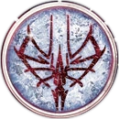
[Lightweaver info card]
Lightwweaver:
-Ideal: I will speak my truth
-Spren Companion: Cryptics
-Surges: Illumination and Transformation
-Description: Masters of illusion who shape light and sound into realistic images, using creativity and emotional insight to change hearts and inspire growth.

[Skybreaker Logo]
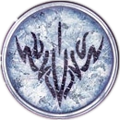
[Skybreaker Info Card]
Skybreaker:
-Ideal: I will seek justice
-Spren Companion: High Spren
-Surges: Gravitation and Division
-Description: Radiants who bind themselves to a strict code or oath and use precise magical force to deliver justice and strike targets with unerring control, while manipulating gravitation to further their reach.

[Stoneward Logo]
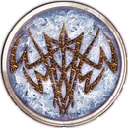
[Stoneward Info Card]
Stoneward:
-Ideal: I will be there when I’m needed
-Spren Companion: Peak Spren
-Surges: Coheision and Tension
-Description: Durable fighters who can strengthen their bodies and the ground around them, granting immense stamina, toughness, and battlefield staying power.

[Elsecaller Logo]
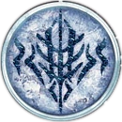
[Elscaller Info Card]
Elsecaller:
-Ideal: I will reach my potential
-Spren Companion: Ink Spren
-Surges: Transformation and Transportation
-Description: Deep thinkers who can step between the physical world and a realm of thought, allowing them to teleport, communicate, and manipulate reality with reason and focus.

[Truthwatcher Logo]

[Truthwatcher Info Card]
Truthwatcher:
-Ideal: I will seek truth
-Spren Companion: Mist Spren
-Surges: Progression and Illumination
-Description: Radiants with the ability to heal and receive visions of hidden truths, letting them repair what is broken and understand things others cannot see.

[Dustbringer Logo]
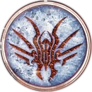
[Dustbringer Info Card]
Dustbringer:
-Ideal: I will seek self mastery
-Spren Companion: Ash Spren
-Surges: Division and Abrasion
-Description: Users who can ignite and intensify destructive energy, giving them the ability to burn, break, or erode physical materials with increasing power.

[Willshaper Logo]
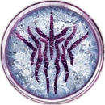
[Willshaper Info Card]
Willshaper:
-Ideal: I will seek freedom
-Spren Companion: Reachers
-Surges: Transportation and Cohesion
-Description: Freedom-seeking adventurers who can reshape solid barriers and manipulate the physical world around them to break restraints and open paths for others.

Page 2: The Enemy: Odium and the Singers

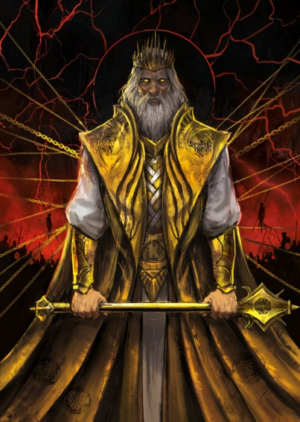
[About Odium]
Odium:
Odium is not just a villain, but a vast, godlike force driven by pure, unyielding hatred. He is the god of the singers, and he grants his eternal warriors, the Fused, new life again and again so they may continue his war. Odium has shattered other divine powers before and seeks to reshape the world by making passion without restraint the ruling principle of all things. If you stand as Radiants, know that he is not just an enemy of humanity, but of any path that values honor, connection, or compassion over conquest and domination.

[Photo of The Singers]
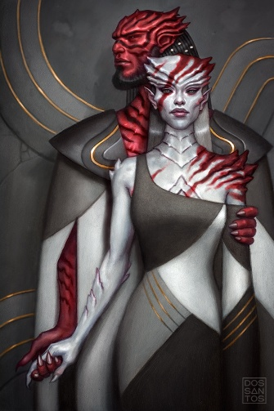
[About the Singers]
The singers are Roshar’s original people, a proud and ancient race who communicate their emotions with songs. There skin is more like shell, decorated with red, black or white patterns, that grows from and protects them. Most follow Odium as their god. He offers them passion, purpose, and the promise of taking back what they believe was lost, and their immortal champions—the Fused—return from death again and again to fight in his name. They are not monsters, but a people with their own history and wounds, yet many now stand beneath Odium’s banner, and if you become Radiants, they are the foes you will most often face, even as we hope one day for peace.
[Photo of the Everstorm]
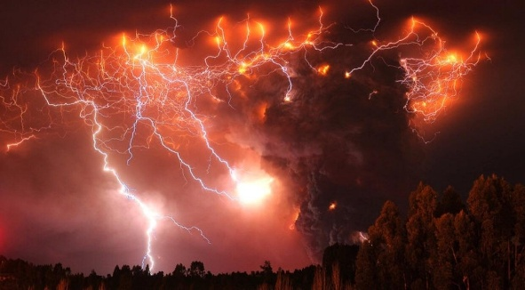
[Photos of the Fused]
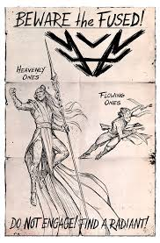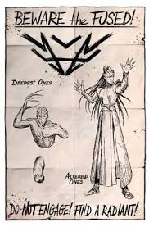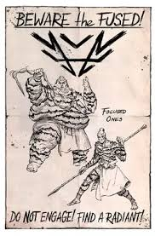
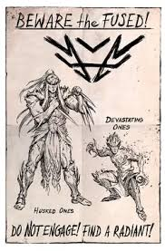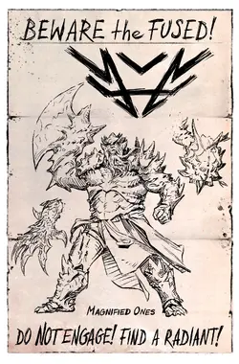
[About the Fused]
The Fused are ancient singer warlords made immortal by Odium, wielding powers similar to Radiants but granted by his direct will rather than oaths. When slain, their souls return and can take new bodies, letting them fight across ages with unmatched experience. They are seasoned, determined, and convinced Odium is their rightful god—formidable foes you will face if you choose the path of the Radiant.
Wireframes
